*NEW DATA POINT for School Nurse Survey*

*Number of students Chronically Absent: Students missing at least 10% or more of school year including excused and unexcused absences.*

The Cognos path and the report description are included.

**Cognos menu path:** Public Folders ‎> Student Management System ‎> Attendance ‎> Day View Attendance

**APSCN Minimum Absence Rate** – This report provides a list of active students who have the prompted absence rate or higher in the selected building. The absence rate is based on the State day view calculation. The absence total and membership total are included in the report along with the absence rate. To get the most current information, the Day Totals calculation must be run for the State Attendance View prior to running this report.

When running the report, there are prompts as below:

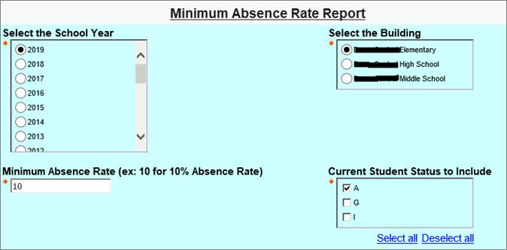

And here is a sample report:

