[the use of this template is optional and should be modified as needed by local districts]
[add your own local letterhead or normal communication headings]
Learning to swim reduces the risk of drowning by 88%, but even skilled and strong swimmers can drown. The following resources can help your family learn more about water safety and connect you with local opportunities for training and education.
54%  Cannot Swim Well Enough  Percentage of Americans who cannot  swim well enough to save themselves. | 50%  Adult Americans Cannot Swim  Percentage of Adult Americans  that do not know how to swim.  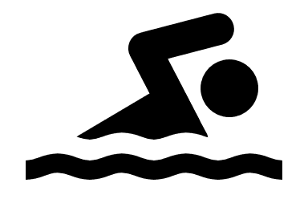 | 88%  Drowning Risk is Reduced  Learning to swim reduces the risk  of drowning by this percentage.

State and National Resources
Water Safety Education
- U.S. Army Corps of Engineers / National Water Safety Program (www.pleasewearit.com)
- U.S. Army Corps of Engineers / Bobber the Water Safety Dog (www.bobber.info)
- American Red Cross / Water Safety (www.rdcrss.org/3uai7FW)
- Arkansas Game and Fish Commission / Boater Education (www.agfc.com/boatered)
Swimming Lessons
- American Red Cross / Swimming Safety (www.rdcrss.org/swimsafety)
- Every Child A Swimmer / Low to no cost scholarships (everychildaswimmer.org)
Local Resources
Water Safety Education
- (add local opportunities for water safety education courses)
Swimming Lessons
- (add local swimming lesson providers)
If you have any questions about these topics, please reach out to (parent coordinator or other contact info) or one of the organizations listed above. The Red Cross believes, and [school district] agrees, that by working together to improve water competency – which includes swimming skills, water smarts and helping others – water activities can be safer… and just as much fun.

